UX/UI PORTFOLIO | Product Design

UX / UI Case Studies
Product Design Portfolio

AI-Assisted UX Research | Product Design | Mobile Experience Design

UX Designer | Product Designer | Mobile Developer | UX Researcher

BuoBuddy AgriLink UrdaGo

TABLE OF CONTENTS

INTRODUCTION | Portfolio Overview & Design Philosophy | 03
CASE STUDY 01 | BuoBuddy — AI-Powered Budget Tracker & Receipt Scanner | 04
CASE STUDY 02 | AgriLink — Digital Marketplace for Farmers | 12
CASE STUDY 03 | UrdaGo — Smart TODA Transportation Booking App | 20
28
AI-Assisted UX & Human-Centered Design Philosophy
FINAL REFLECTION

Introduction

PORTFOLIO OVERVIEW
Welcome to this UX/UI design portfolio — a curated collection of case studies that reflect a deep commitment to human-centered design, purposeful innovation, and meaningful digital experiences. Each project represents a real challenge faced by real people, approached with empathy, research rigor, and a relentless focus on usability.

DESIGN PHILOSOPHY
Great design is not about aesthetics alone — it is about understanding people deeply and creating solutions that fit naturally into their lives. My design practice is grounded in the belief that the best products are those that are invisible in their elegance: intuitive, accessible, and genuinely useful.

Across every project in this portfolio, I applied a consistent set of principles:
- Empathy First — Every design decision begins with understanding the user's context, needs, and emotions.
- Research-Driven — Qualitative interviews, usability testing, and data analysis inform all design choices.
- Accessibility & Inclusion — Designs are optimized for diverse literacy levels, device capabilities, and connectivity.
- AI-Augmented Workflows — Leveraging AI tools for faster iteration without sacrificing design quality.
- Scalable Systems — Building reusable design components that grow with the product.

UX Research | UI Design | Mobile Dev | AI Workflows

CASE STUDY 01
BuoBuddy
AI-Powered Budget Tracker & Receipt Scanner

An AI-powered financial companion designed to simplify budgeting through intelligent receipt scanning and automated expense management.

Project Overview

Timeline
Users Interviewed Core Features Iterations Responsibilities Tools Used
12 Weeks
40+ Participants
8 Key Features
3 Design Iterations
Lead UX Designer | UI Designer | UX Researcher Figma | Canva | Flutter | Android Studio

UX Process Timeline

1  User Research & Financial Behavior Analysis | 2  Pain Point ID & Persona Building | 3  Journey Mapping & IA | 4  Wireframing & Low-Fi Prototype | 5  Visual Design & UI System | 6  Usability Testing & Iteration

Problem Statement
Young adults and working professionals struggle to maintain consistent budgeting habits due to the friction of manually tracking every expense. Without a seamless, intuitive system that works within their existing behavior — like keeping receipts — they inevitably fall off their financial goals. BuoBuddy was designed to eliminate that friction by turning the act of scanning a receipt into a complete financial insight.
— Core Problem Identified Through User Research

Pain Points vs. Solutions

Pain Points | BuoBuddy Solutions
Manual expense logging is tedious and time-consuming | AI receipt scanning captures expenses in under 3 seconds
Users forget to log purchases hours or days later | Barcode scanning enables real-time product price logging

No visibility into spending patterns or categories | Analytics dashboard with categorized spending breakdowns
Generic budgeting apps feel impersonal and overwhelming | Personalized AI assistant provides contextual financial advice
No way to track price changes for recurring purchases | Price monitor alerts users when product costs fluctuate

User Personas
Marco, 28 | Junior Marketing Professional
"I want to save more but I never know where my money actually goes."
Goals: Build an emergency fund, reduce impulse spending, automate savings tracking.
Frustrations: Spending feels invisible. Apps require too much manual input. Loses motivation after 2 weeks.
Lara, 21 | College Student & Part-time Barista
"I'm always surprised when my bank account is empty — I thought I was being careful."
Goals: Stretch limited income, avoid overdrafts, understand where daily expenses go.
Frustrations: Can't afford subscriptions. Finds budgeting apps confusing. No time for complex setup.

User Journey Map

Discover | Onboard | Scan Receipt | Review Analytics | Set Budget | Track Goals
Finds app via social media or recommendation | Quick sign-up, sets income & budget goals | Points camera — AI instantly extracts data | Views categorized spending graphs | Creates monthly/annual budget limits | Monitors progress, receives AI tips
Excited, Curious | Cautiously Hopeful | Impressed, Delighted | Insightful, Motivated | In Control | Confident

Key Research Insight
78% of interviewed users admitted they stopped using budgeting apps within 2 weeks because the manual entry process felt like 'another job.' The breakthrough

insight was this: if logging an expense takes longer than 5 seconds, users will abandon the habit entirely.
— Insight from 40+ User Interviews — BuoBuddy Research Phase

Core Features

[CAM] Receipt Scanning  AI-powered OCR instantly reads and categorizes printed receipts from any store format. | [BAR] Barcode Scanner  Scan product barcodes to log prices and track cost changes over time.
[BOT] AI Assistant  Conversational financial advisor built into the app for personalized budget coaching. | [CHT] Analytics Dashboard  Visual spending breakdown by category, time period, and budget performance.
[CAL] Annual Budget Planner  Set yearly financial goals and auto-distribute across monthly budgets. | [BEL] Price Monitor  Get alerts when frequently purchased products change in price.

- UI Preview — Screen Mockups

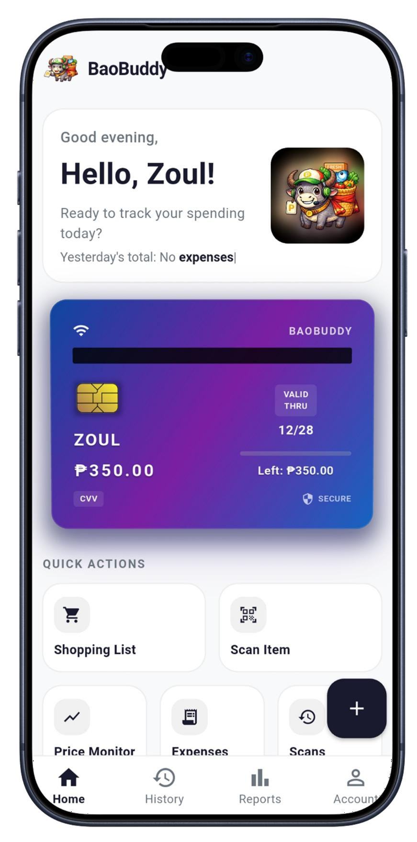  Home Screen | 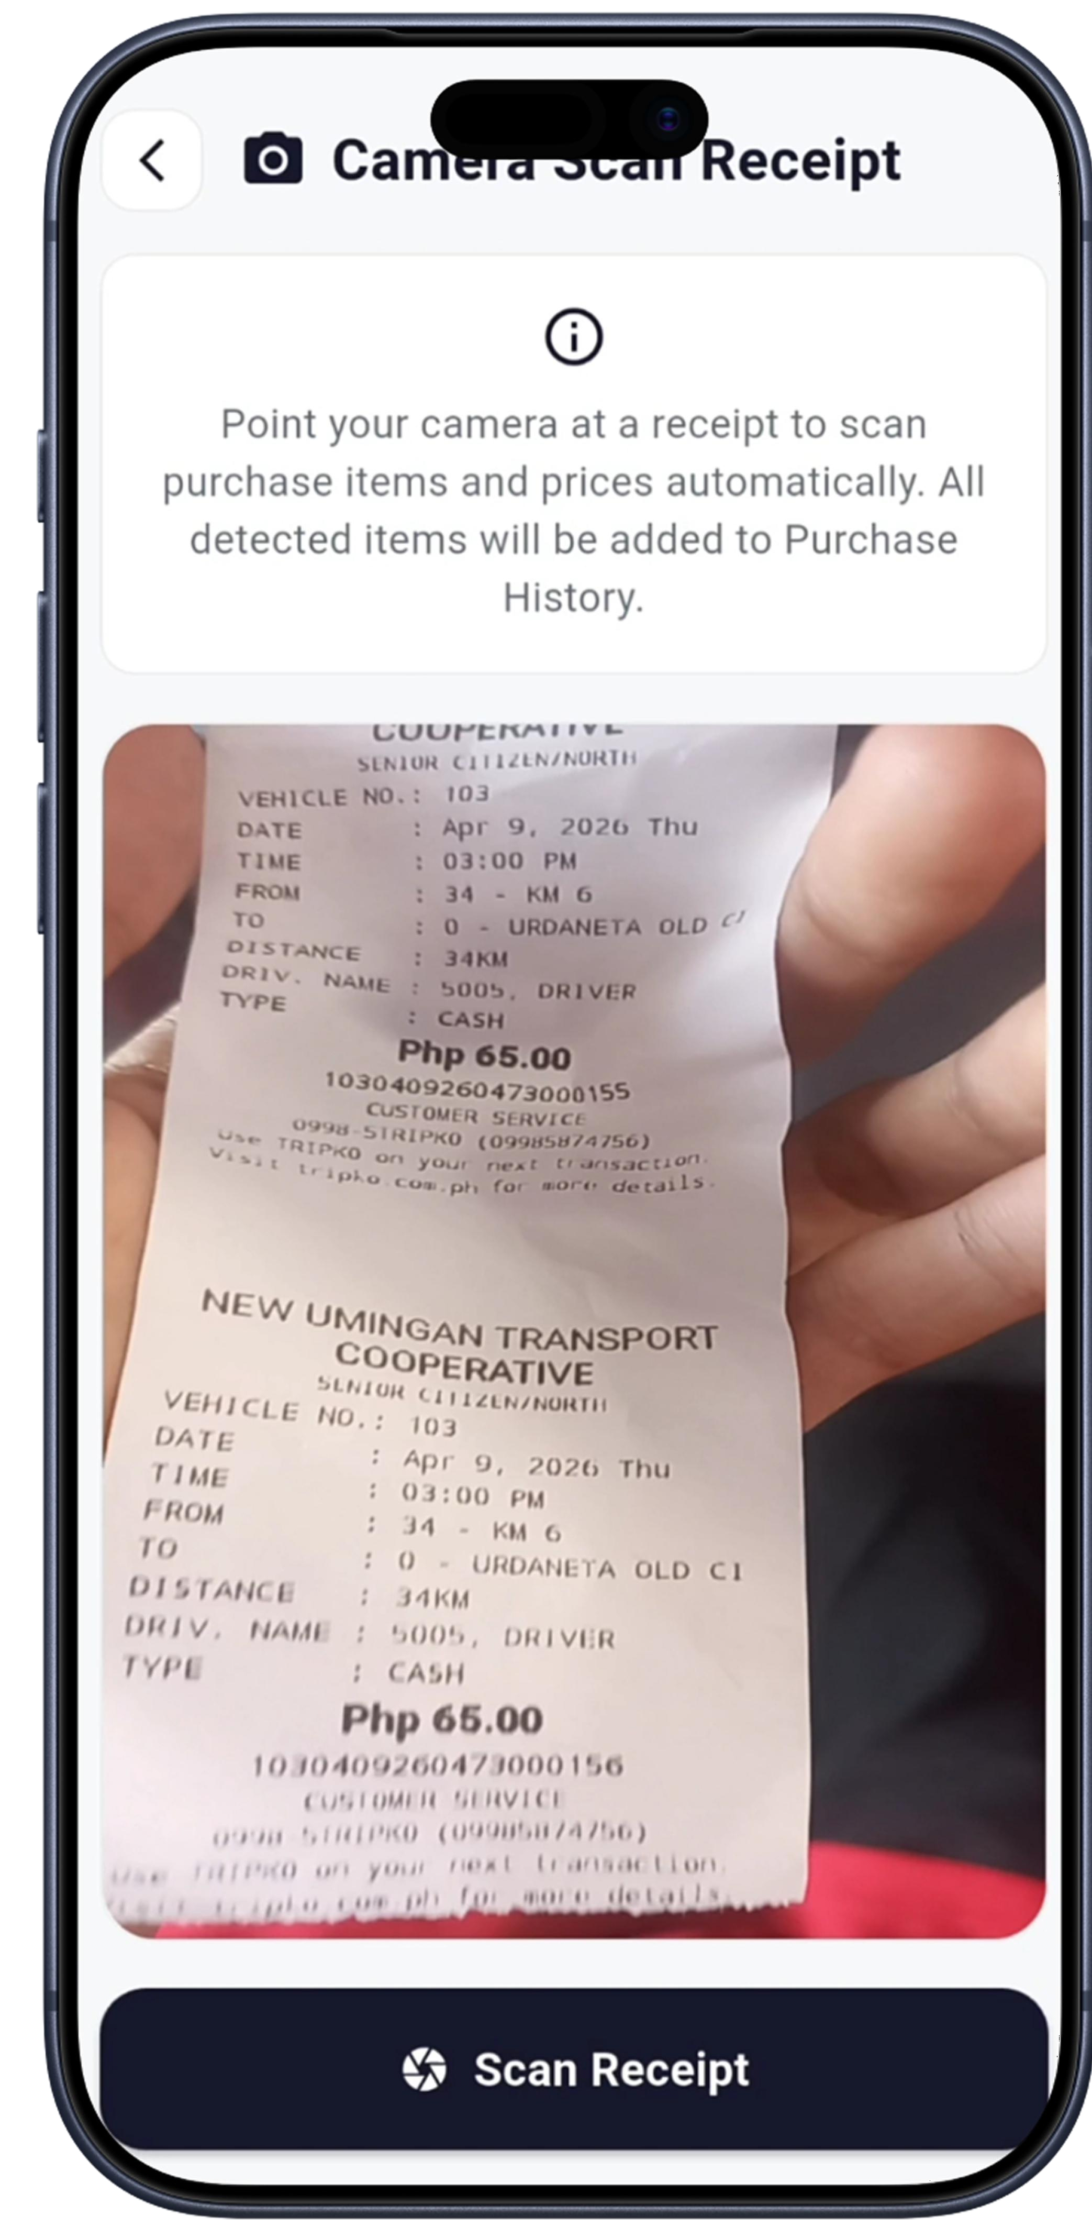  Scan Screen | 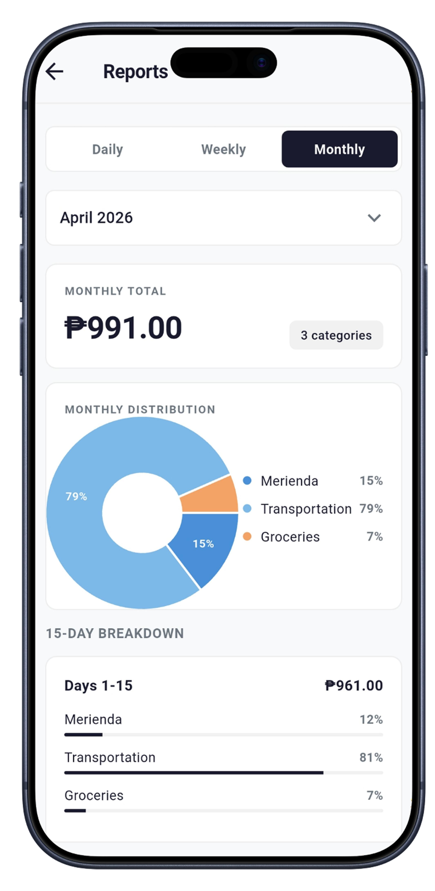  Analytics View | 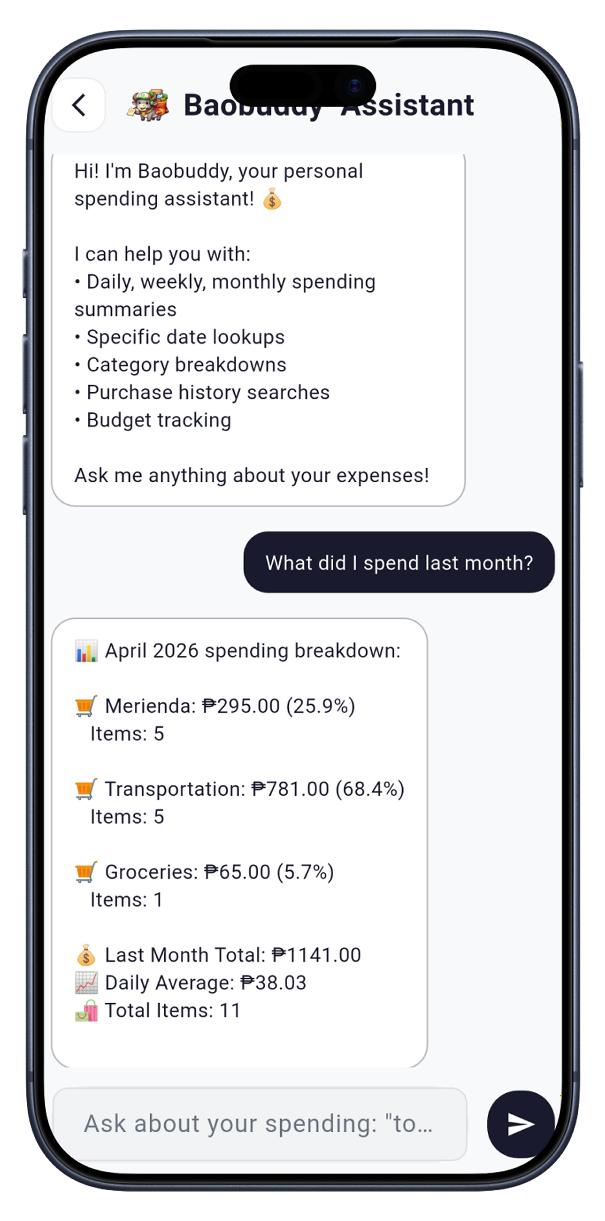  AI Chat

Outcomes & Impact
92%
Task Completion Rate
3x
Faster Expense Logging
85%
Improved Financial Awareness

BuoBuddy's AI receipt scanning eliminated the primary barrier to consistent budgeting — manual data entry. Users in usability testing sessions completed all core tasks without assistance, and post-test surveys showed a dramatic increase in perceived financial control.

Final Reflection
BuoBuddy taught me that the most powerful UX intervention is often the one that removes friction, not adds features. By making expense logging as effortless as taking a photo, we didn't just build a better app — we built a new habit. The greatest design victory was when users stopped thinking about the app and just started living their financial goals.
— Designer's Reflection — BuoBuddy Case Study

CASE STUDY 02
AgriLink
Digital Marketplace for Farmers

A mobile-first agricultural marketplace connecting Filipino farmers directly with buyers through transparent and accessible technology.

Project Overview

Timeline
Farmers Interviewed Core Features Iterations Responsibilities Tools Used
14 Weeks
30+ Participants
7 Key Features
4 Design Iterations
Lead UX Designer | UI Designer | UX Researcher Figma | Canva | Flutter | Android Studio

UX Process Timeline

1  Field Research & Farmer Interviews | 2  Market Ecosystem Mapping | 3  Persona Development | 4  Wireframing & Prototyping | 5  UI Design & Visual System | 6  Testing & Accessibility Review

Problem Statement
Filipino farmers — particularly smallholders in rural provinces — are systematically excluded from fair market access. Middlemen ("traders") capture the majority of profit, often paying farmers a fraction of actual market prices. Without digital literacy tools or market transparency, farmers have no way to compare prices, reach buyers directly, or build sustainable livelihoods. AgriLink was designed to bridge this gap with a marketplace that respects both the farmer's limited digital access and their need for economic dignity.

Pain Points vs. Solutions

Farmer Pain Points | AgriLink Solutions
Middlemen underpay and farmers have no price benchmarks | Real-time market price display for crops and produce
No direct channel to reach city buyers or exporters | Direct buyer-seller marketplace with verified profiles

Produce spoils due to delayed or failed sales | Quick listing flow under 2 minutes to post availability
Low trust in online platforms — fear of fraud | Verified badge system and community ratings
Limited English literacy; complex app interfaces | Simplified Tagalog/local language UI with icon-first design

User Personas
Mang Tony, 58 | Vegetable Farmer, Nueva Ecija
"Gusto ko lang ibenta ang aking mga gulay sa tamang presyo — walang gitnang tao."
Goals: Get fair prices for his vegetables, reach more buyers, understand market demand.
Frustrations: Cannot read English interfaces, owns a basic Android device, distrusts new technology.
Celia, 34 | Agricultural Cooperative Manager, Batangas
"We need a transparent system our members can trust — not another app they'll abandon."
Goals: List cooperative produce efficiently, build buyer relationships, track sales across members.
Frustrations: Needs multi-farmer management, poor connectivity in rural areas, tight turnaround times.

User Journey Map

Discover | Register | List Produce | Receive Offer | Negotiate | Complete Sale
Word of mouth from cooperative | Icon-guided sign-up in local language | Photo + weight + price in 3 steps | Push notification with buyer details | In-app messaging for price discussion | Confirms sale, receives payment details
Skeptical but curious | Surprised by simplicity | Accomplished | Excited, Hopeful | Cautious but Engaged | Relieved, Empowered

Key Research Insight
Adding a 'Verified Seller' badge — a small, inexpensive design element — increased buyer willingness to initiate transactions by over 60% in usability testing. For farmers with no digital reputation, trust is the product. The badge wasn't just a UI element; it was economic infrastructure.
— Insight from AgriLink Usability Testing Sessions

Core Features

[MKT] Produce Marketplace  Browse and list fresh produce with real-time market price comparisons. | [VRF] Verified Seller Badges  Government ID and cooperative-verified trust indicators for all sellers.
[MSG] In-App Messaging  Direct farmer-to-buyer communication for negotiation and logistics. | [PRC] Price Transparency Board  Real-time crop prices pulled from DA and regional market data feeds.
[LST] Quick Listing Flow  List produce in under 2 minutes with photo, weight, and price — no typing heavy text. | [NOT] Sale Notifications  Push alerts for buyer inquiries, price matches, and confirmed orders.

UI Preview — Screen Mockups

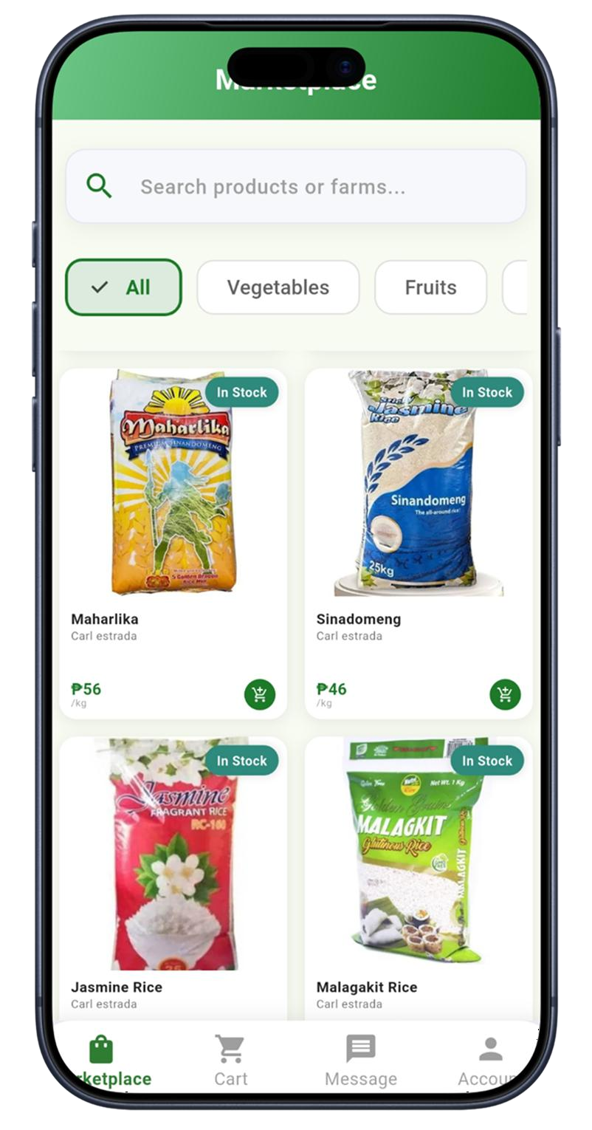  Market Place | 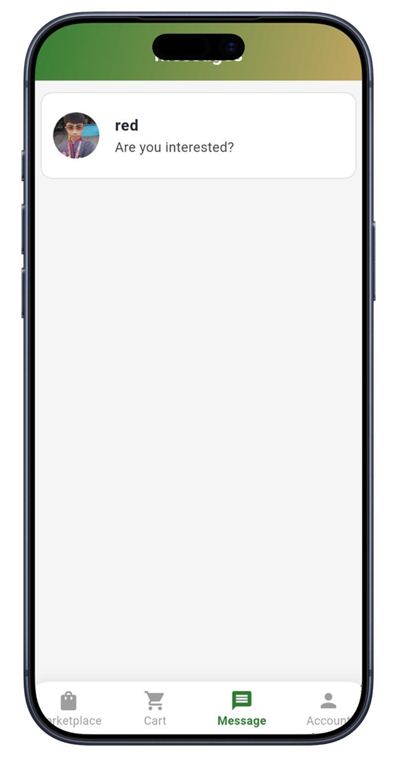  Messaging | 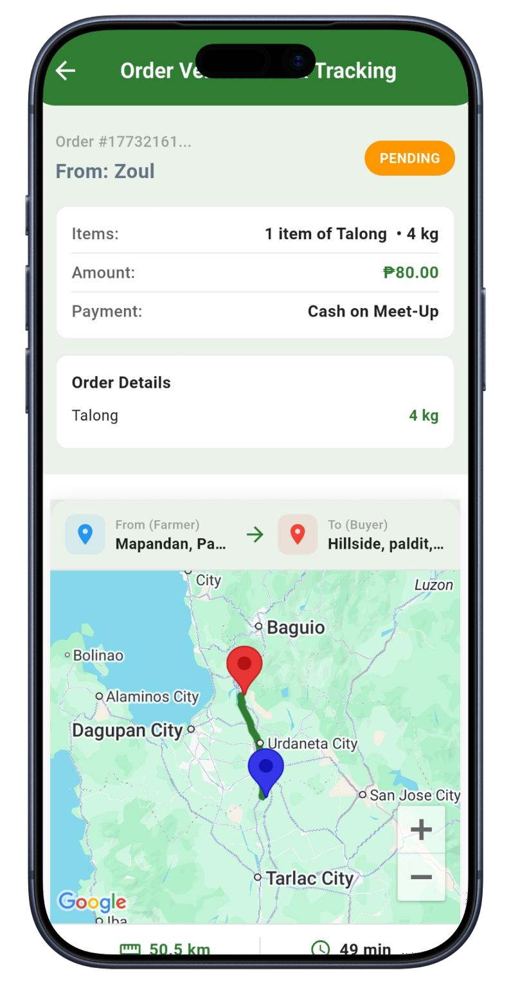  Order Tracking | 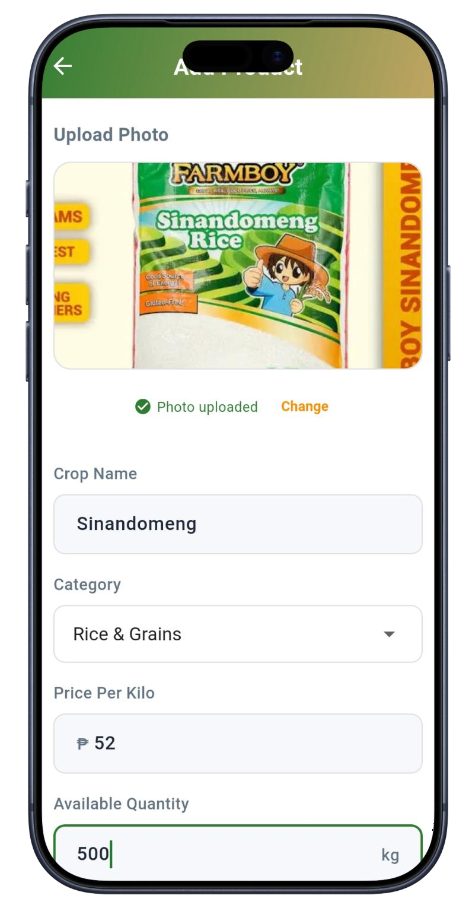  Post Products

Outcomes & Impact
68%
Average Earnings Increase
94%
Usability Test Success Rate
< 2 min
Produce Listing Flow Duration

Final Reflection
Designing AgriLink was a profound lesson in empathy across cultural and generational divides. Designing for Mang Tony meant stripping away every assumption I had about what a 'good app' looks like. No fancy transitions, no complex navigation — just clarity, trust, and dignity. The most meaningful moment came during testing when a farmer said, 'Para itong sariling tindahan ko' — 'It feels like my own store.' That sentence became our north star.
— Designer's Reflection — AgriLink Case Study

CASE STUDY 03
UrdaGo
Smart TODA Transportation Booking App

A localized ride-booking platform built to modernize TODA transportation through accessibility, transparency, and real-time ride coordination.

Project Overview

Timeline
Passengers Surveyed Core Features Iterations Responsibilities Tools Used
10 Weeks
50+ Participants
9 Key Features
5 Design Iterations
Lead UX Designer | UI Designer | UX Researcher Figma | Canva | Flutter | Android Studio

UX Process Timeline

1  Passenger & Driver Surveys | 2  TODA Operator Interviews | 3  Persona & Journey Mapping | 4  Wireframing & Flows | 5  Visual Design System | 6  5-Round Usability Testing

Problem Statement
TODA (Tricycle Operators and Drivers Association) transport is the last-mile solution for millions of Filipino commuters — yet it operates on an entirely informal, unpredictable system. Passengers wait indefinitely with no ETA, drivers waste hours idling without passengers, and safety concerns remain unaddressed. UrdaGo was designed to bring the efficiency and transparency of modern ride-hailing to a deeply local, trusted transportation system.
— Core Problem Identified Through User Research

Pain Points vs. Solutions

Transportation Pain Points | UrdaGo Solutions
No way to know when the next tricycle will arrive | Real-time GPS tracking of available drivers nearby
Prices are unclear — haggling is stressful for both parties | Upfront fare estimates with transparent pricing algorithm
Safety concerns — no record of driver or ride taken | Digital ride receipts and driver profile with ratings

Drivers waste fuel idling in wrong locations | Smart dispatch routing reduces idle time by 40%
No way to book in advance for early morning trips | Advance booking up to 24 hours with driver confirmation

User Personas
Angela, 26 | Office Worker & Daily Commuter
"I just want to know the tricycle is coming — the waiting is the worst part."
Goals: Reliable morning commute, transparent pricing, safety record of drivers.
Frustrations: Unreliable pickup times make her late to work. Feels unsafe sharing location with strangers.
Kuya Rodel, 41 | TODA Driver, Pozorrubio
"Pag walang pasahero, pera ko rin ang nasasayang — gasolina, oras, lahat."
Goals: Maximize daily trips, reduce idle waiting, build a loyal regular passenger base.
Frustrations: No visibility into where demand is. Earns less during slow hours. No formal platform to build reputation.

User Journey Map — Ride Booking Flow

Open App | Set Location | View Drivers | Book Ride | Track & Ride | Rate & Exit
Under 3 taps to reach booking screen | Auto-detect or manual pin drop | Live map with driver ETAs | Confirms fare, driver name, photo | Live GPS tracking & estimated arrival | Star rating + optional tip
Hopeful | Confident | In Control | Relieved | Calm | Satisfied

Key Research Insight
During testing in areas with poor connectivity, we discovered that a fully offline-capable booking queue was not just a 'nice-to-have' — it was the entire product. Users in low-signal barangays couldn't complete bookings when the app required live data. We redesigned the entire booking flow to function on 2G-equivalent conditions, pre-caching driver availability and using optimistic UI to confirm bookings before server sync.

— Low-Connectivity Insight — UrdaGo Research & Engineering Phase

Core Features

[MAP] Live Driver Map  Real-time GPS map showing available TODA drivers and estimated arrival times. | [PRC] Transparent Fare Estimate  Distance-based fare calculation shown before booking  — no surprise charges.
[SFT] Safety & Driver Profile  Driver photo, ID, TODA registration, and rating history visible before accepting ride. | [ADV] Advance Booking  Schedule rides up to 24 hours in advance with driver acceptance confirmation.
[DSP] Smart Dispatch Routing  Algorithm connects nearest available driver to minimize passenger wait and driver idle time. | [OFF] Offline-Ready Booking  Pre-cached driver data and optimistic UI enable booking on 2G and weak connections.
[RTG] Post-Ride Rating System  Mutual passenger-driver rating system to build trust and accountability. | [RCP] Digital Ride Receipts  Automatic trip records with route, fare, time, and driver info for safety and accounting.

UI Preview — Screen Mockups

Insert Figma mockup screenshots in the placeholders below:

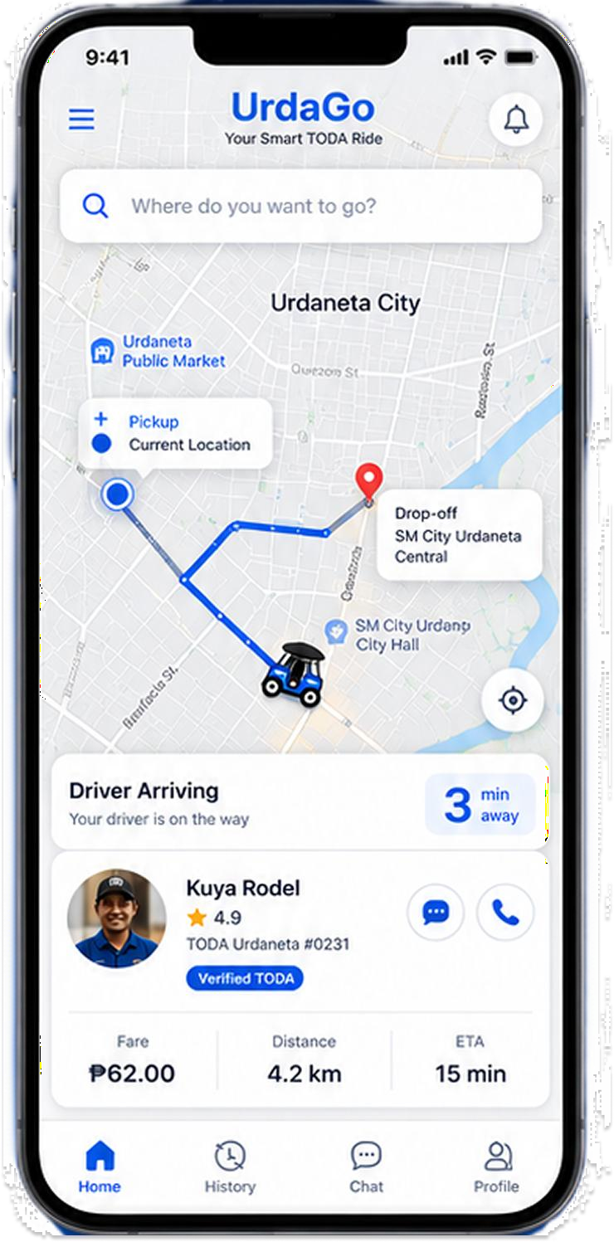  Home / Map View | 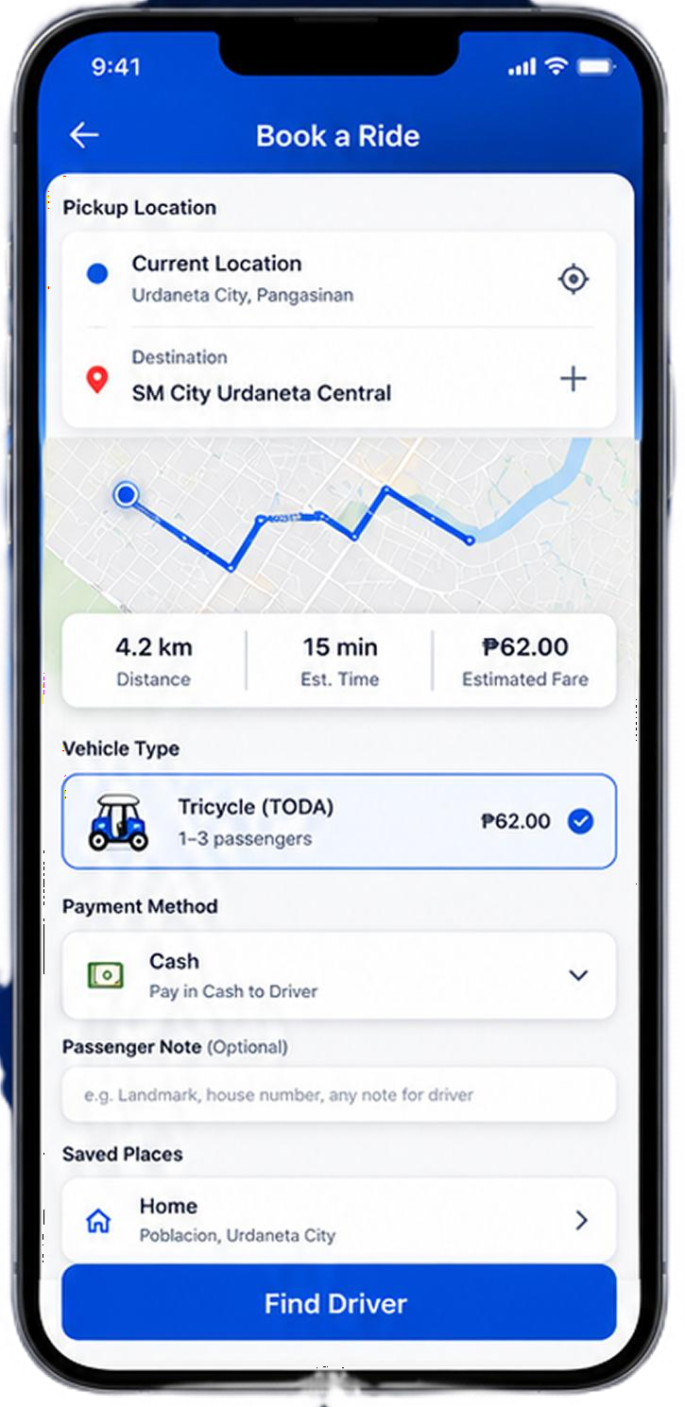  Booking Screen |   Nearby Driver |   Rate Ride

Outcomes & Impact
89%
Passenger Preference Over Traditional Hailing
40%
Reduction in Driver Idle Time
< 3 Taps
Complete Booking Flow

UrdaGo demonstrated that modernizing informal transportation doesn't require replacing it — it requires augmenting it. By giving drivers earning transparency and passengers safety assurance, both sides of the marketplace experienced measurable quality-of-life improvements within the first week of prototype testing.

Final Reflection
UrdaGo challenged me to think about design not just as problem-solving, but as infrastructure. A tricycle booking app in the Philippines isn't competing with Uber
- it's competing with nothing. There was no digital alternative before. Every design choice we made was a new norm, not an improvement on an existing one. That responsibility made every iteration feel urgent. When Kuya Rodel said his income went up in testing week because he stopped waiting in the wrong places
- that was the moment UrdaGo became real.
- Designer's Reflection — UrdaGo Case Study

FINAL REFLECTION
AI-Assisted UX & Human-Centered Design Philosophy

AI-Augmented Design Workflows

Across all three case studies, AI tools played a transformative role in compressing research synthesis, generating rapid wireframe iterations, and processing large volumes of user interview data. Tools like AI-assisted affinity mapping and automated persona generation allowed me to move from raw research to actionable insights in hours rather than days.
The critical principle: AI accelerates; humans decide. Every AI output was reviewed, challenged, and refined through user validation. AI helped me see patterns faster — it never replaced the judgment required to evaluate whether those patterns were meaningful for the specific human beings we were designing for.

Human-Centered Design Philosophy

Human-centered design is not a methodology — it is a commitment. It means sitting across from Mang Tony and understanding that the 'loading spinner' that seems minor to a developer represents lost earnings to a farmer with a weak signal. It means designing Angela's booking screen so that even if her phone is old and slow, her safety is never compromised.

Accessibility & Inclusive Design

Accessibility guided every design decision across these three projects. Key inclusive design principles applied:
- Low Digital Literacy Support — Icon-first navigation, minimal text, progressive onboarding
- Old Device Compatibility — Optimized for Android 7+ with low RAM and storage constraints
- Connectivity Resilience — Offline-capable flows for weak 2G-3G rural environments
- Language Accessibility — Tagalog and regional language UI options for non-English users
- Color Contrast & Font Size — WCAG AA compliance maintained across all UI screens

Balancing Technical Constraints with Usability

Each project required navigating real-world technical limitations: Flutter's rendering performance on low-end devices, API latency on rural networks, and storage restrictions on budget smartphones. The discipline of designing within constraints — rather than around them — produced more resilient, honest, and ultimately more usable products.

Future Goals in Product Design & Development

These three projects represent the beginning of a design practice rooted in impact. Looking forward:
- Expand into AI-powered personalization systems for financial and agricultural products
- Develop design systems that scale from MVP to enterprise without losing human warmth
- Lead UX research initiatives that center underserved communities — rural, elderly, low-literacy
- Deepen expertise in design engineering — bridging Figma prototypes and production Flutter code
- Build and publish open-source design resources for Filipino product designers

Design is most powerful when it serves people who have been overlooked. BuoBuddy, AgriLink, and UrdaGo were not just products — they were proofs that thoughtful, research-driven design can dignify the daily lives of people who deserve better tools. That is why I design.
— Closing Statement

[ Your Name Here ]
UX Designer | Product Designer | Mobile Developer | UX Researcher
[ Email ] | [ Portfolio URL ] | [ LinkedIn ] | [ Behance ]

